VELAMMAL ENGINEERING COLLEGE

-Surapet,Chennai,TamilNadu600127

DEPARTMENTOFELECTRONICS AND COMMUNICATION ENGINEERING.WEB PHISHINGDETECTION(**ASSIGNMENT3)**

**DATE** :10-10-2022

**PROBLEM:**TOPERFORMABALONEAGEPREDICTION

**NAME** :SUBHIKSHA P

**OUTPUT:**

**SCREENSHOTS:**

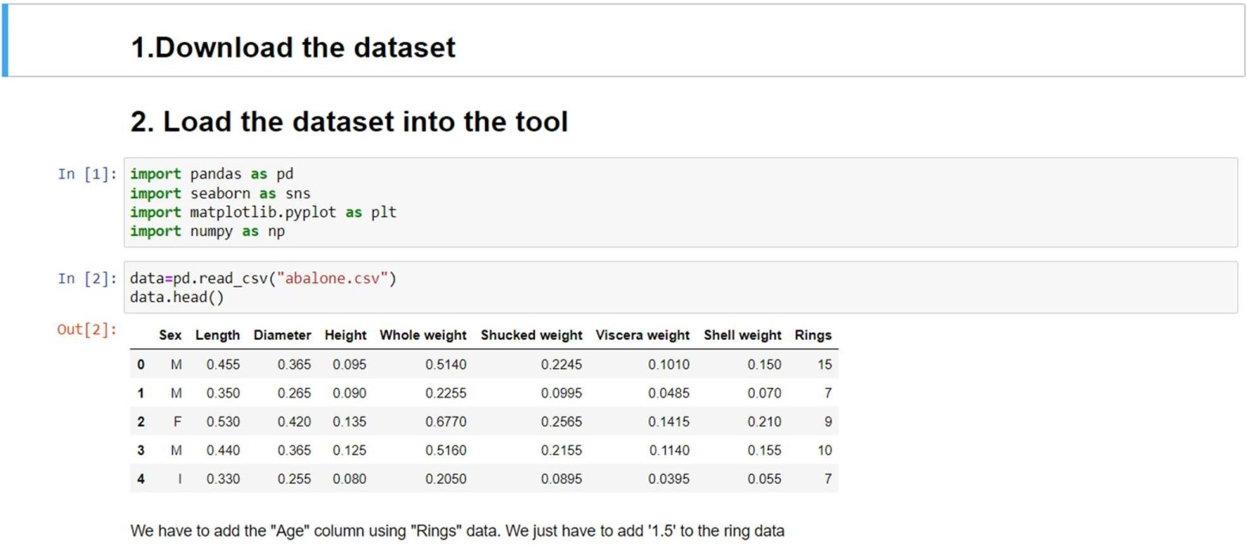

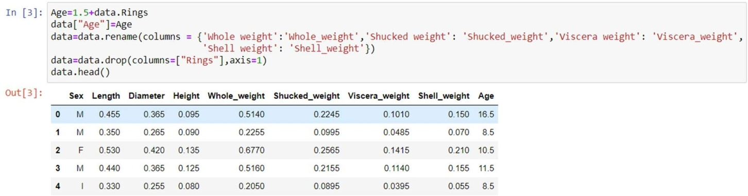

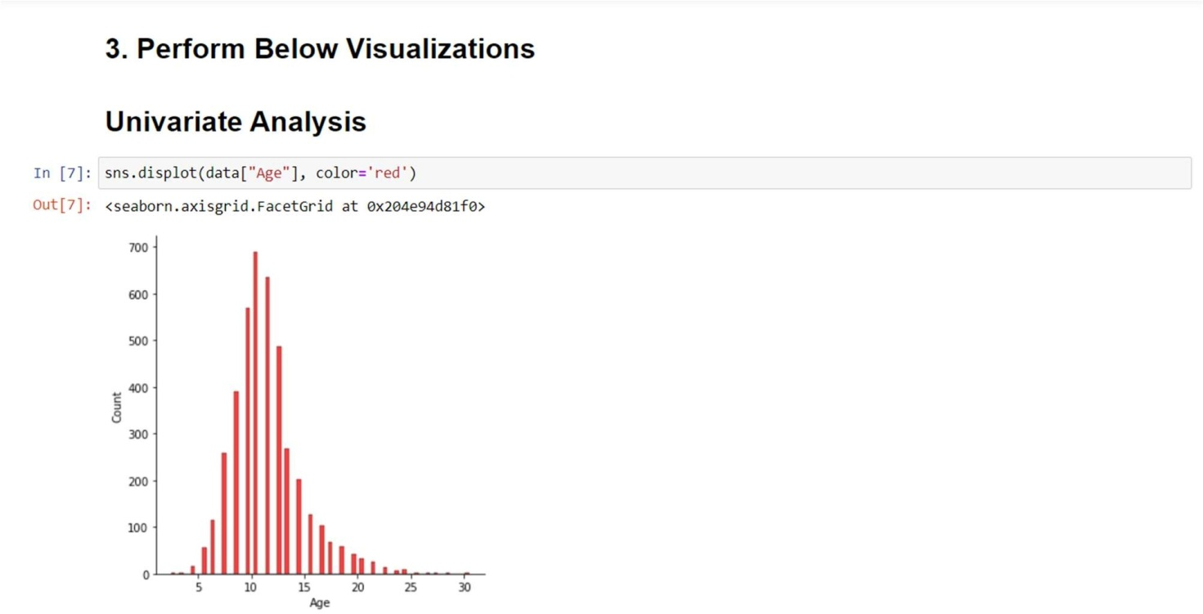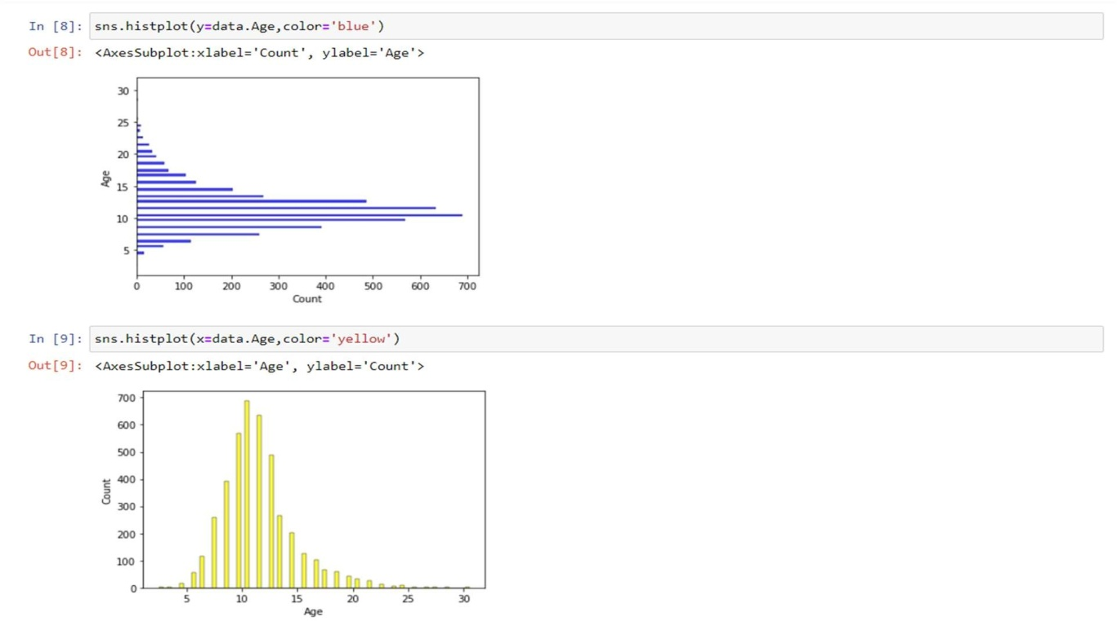

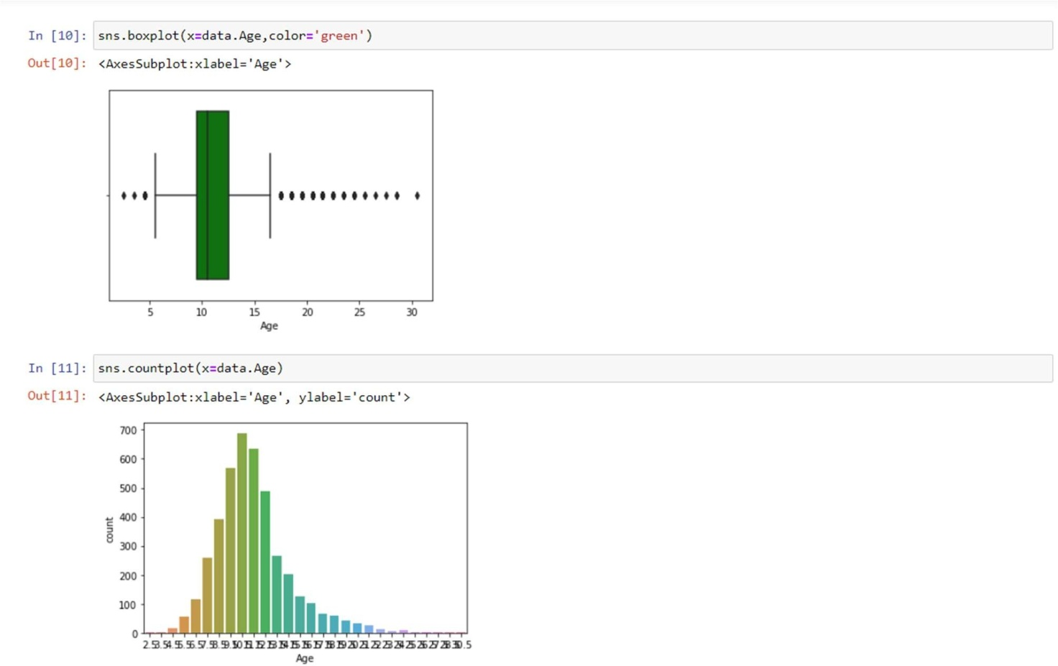

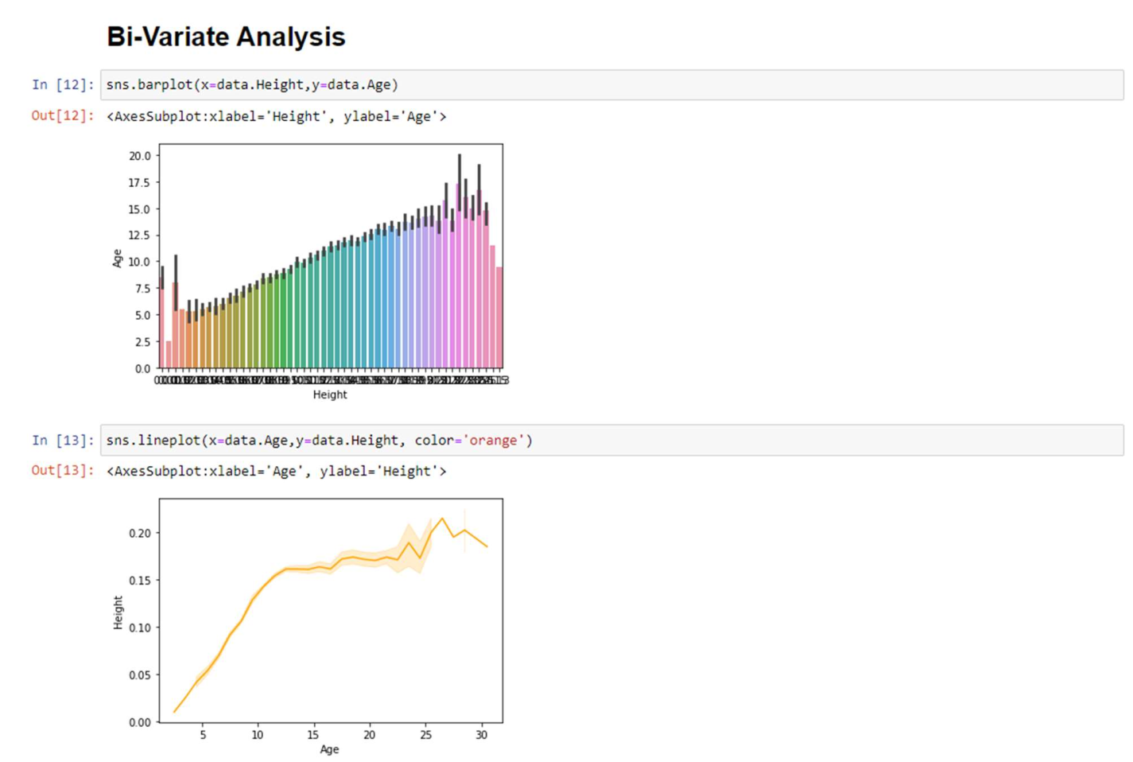

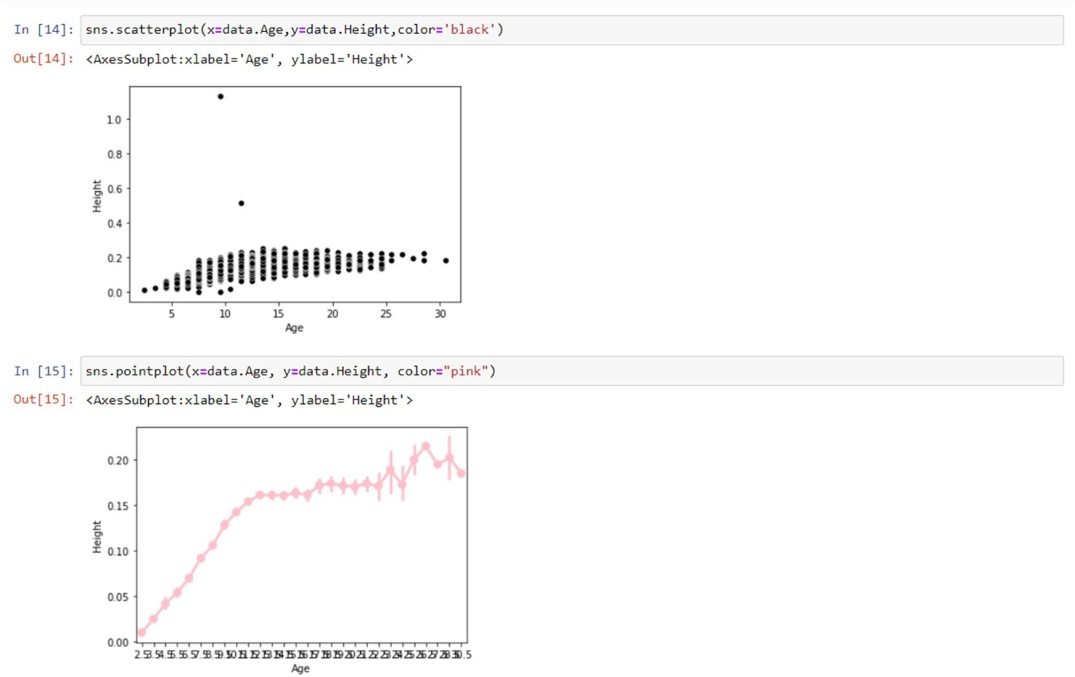

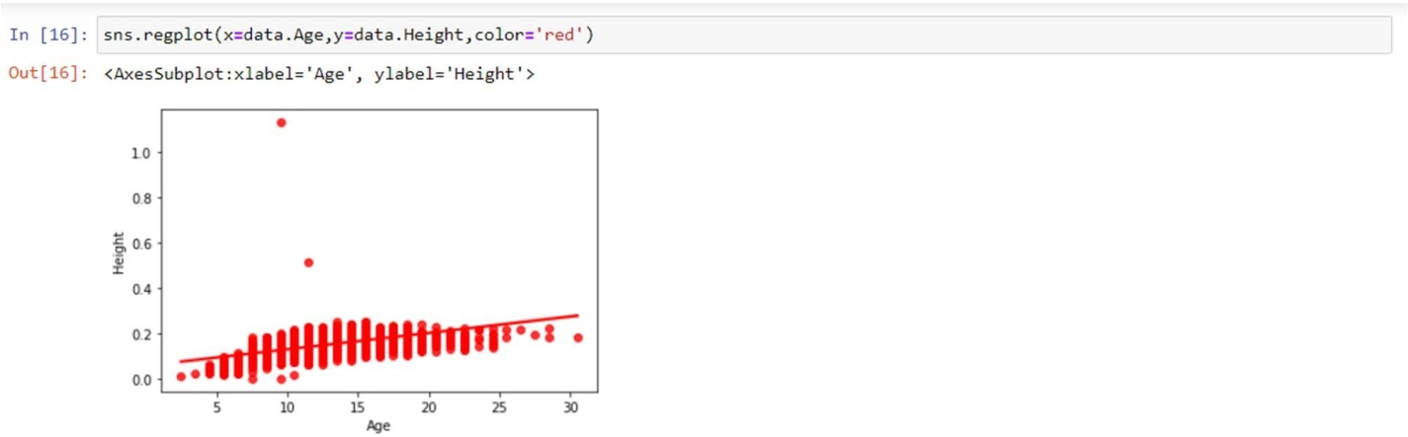

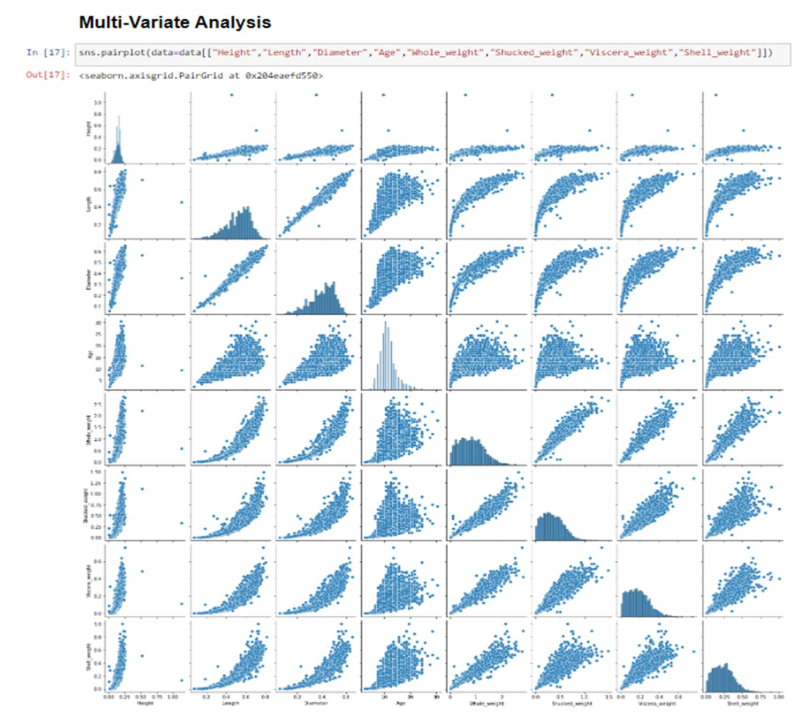



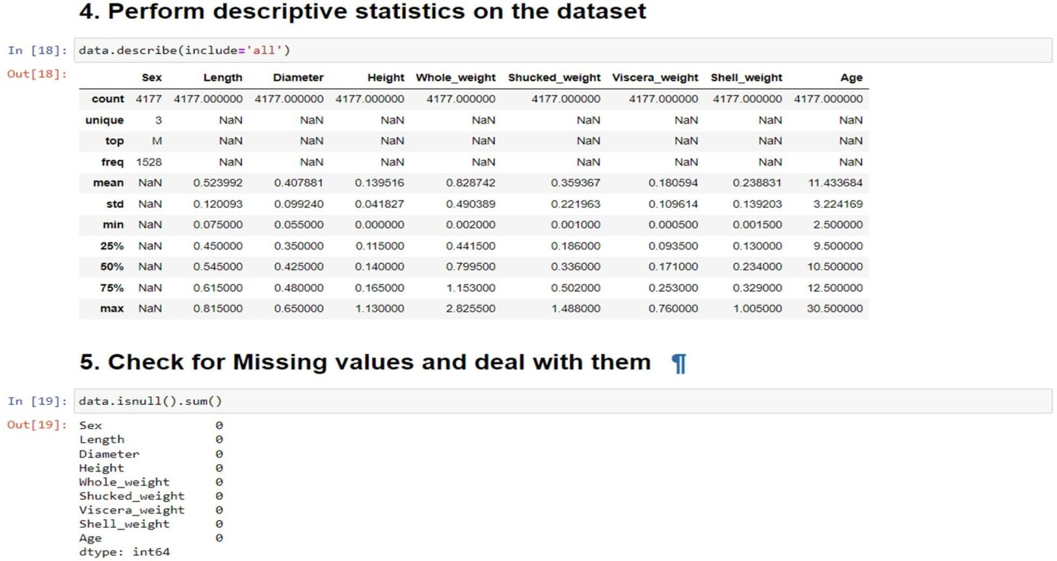

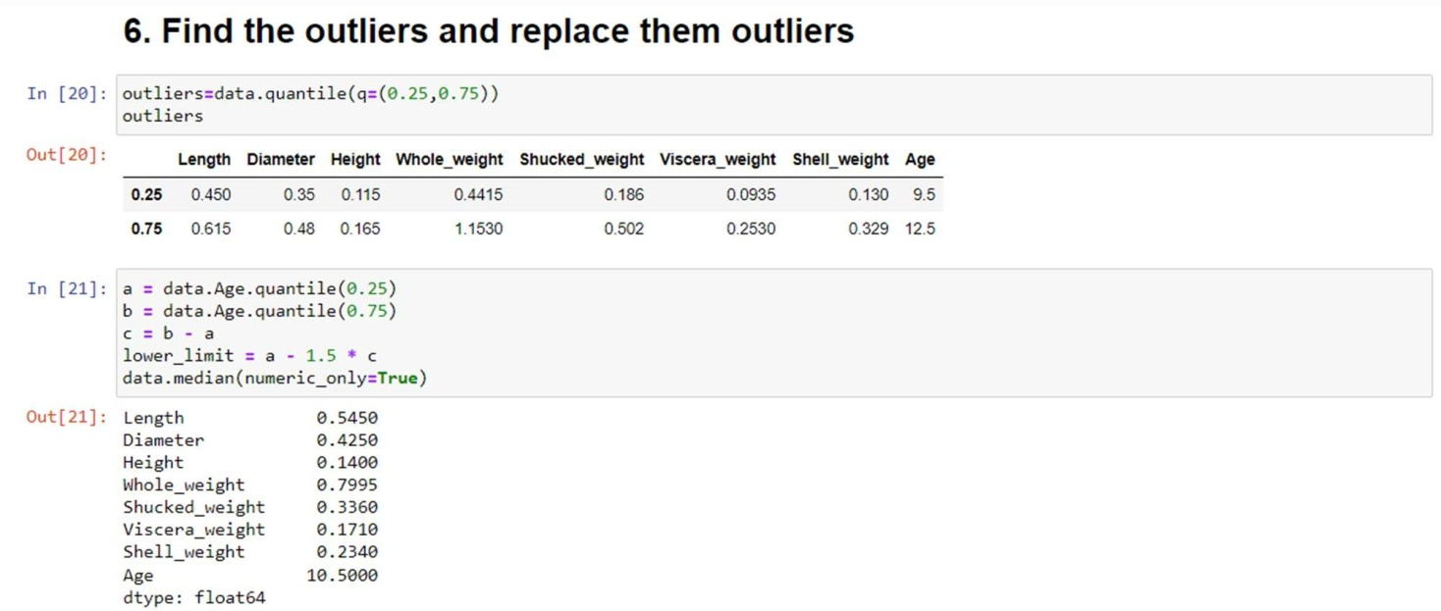



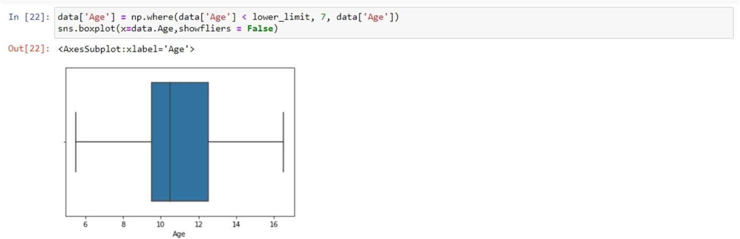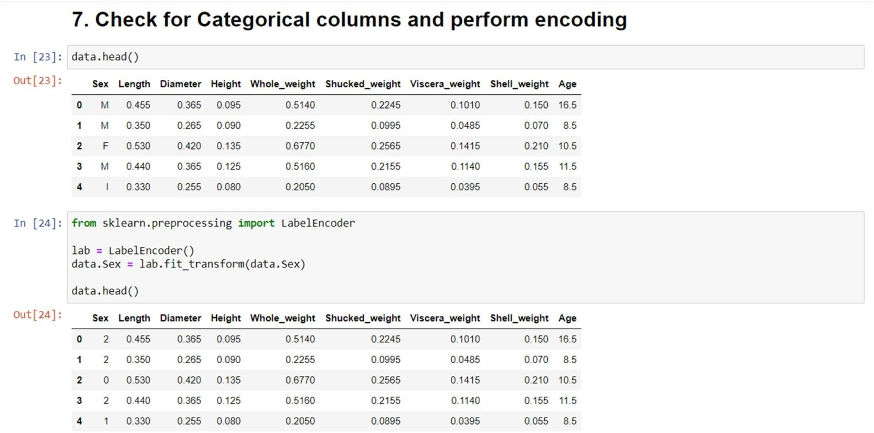



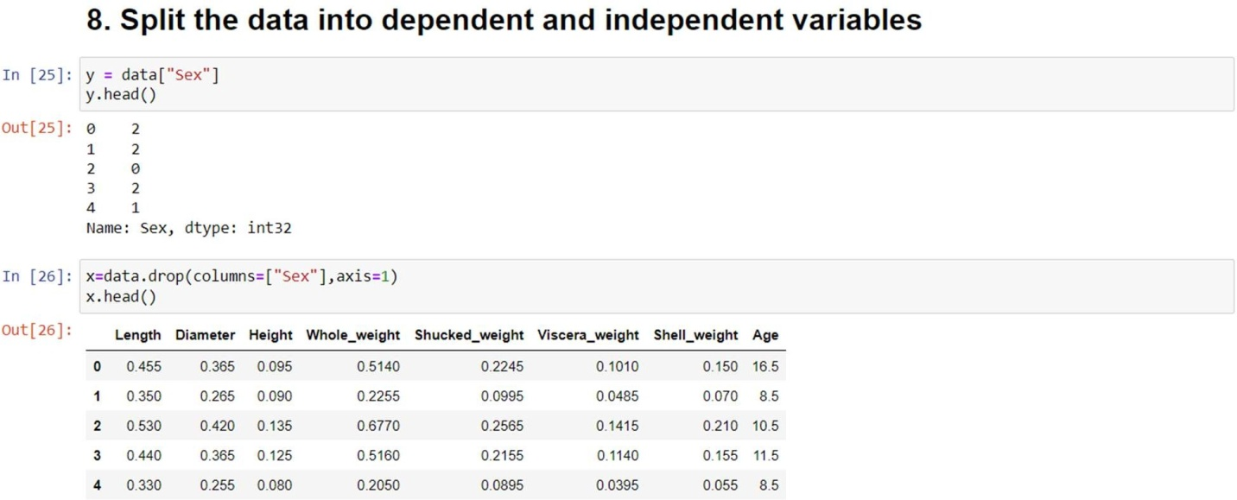

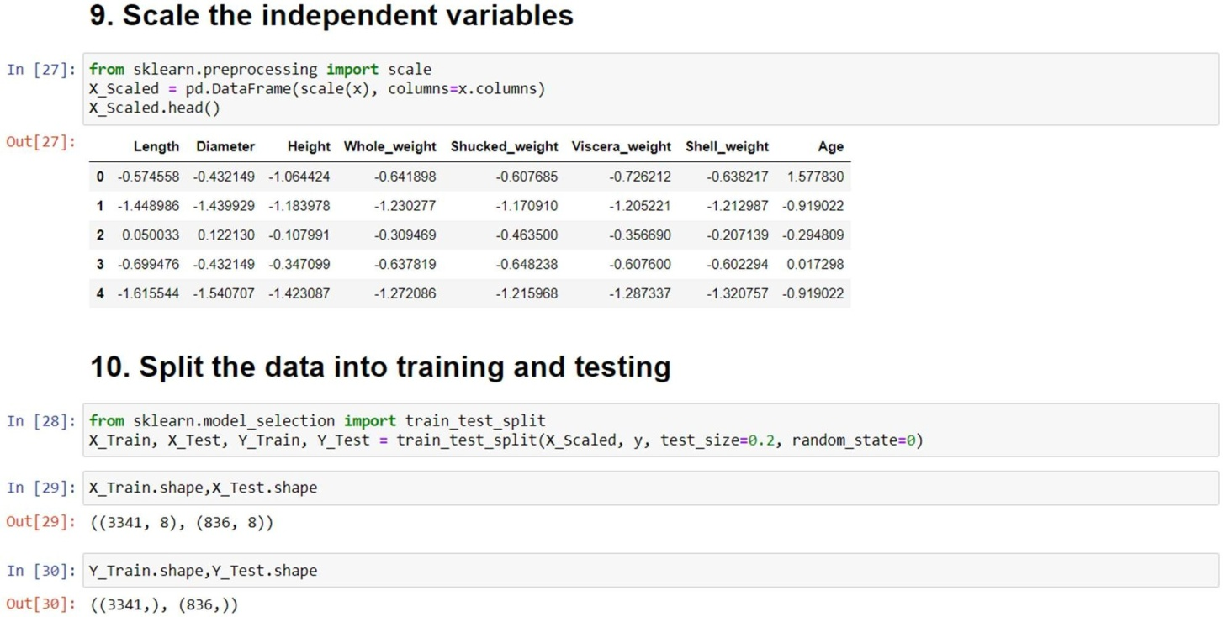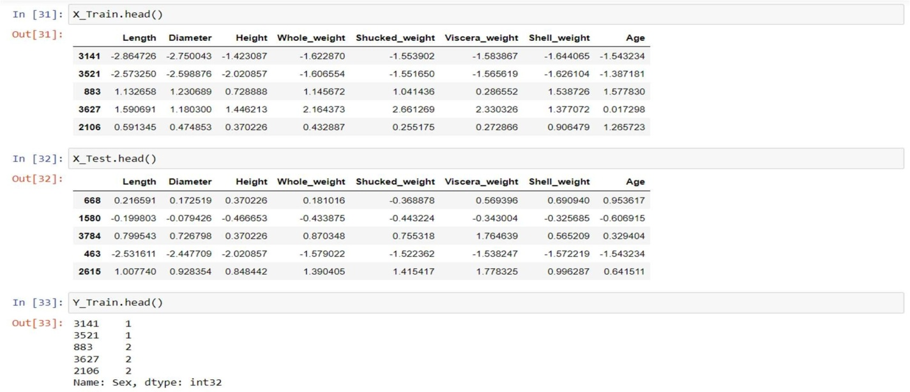

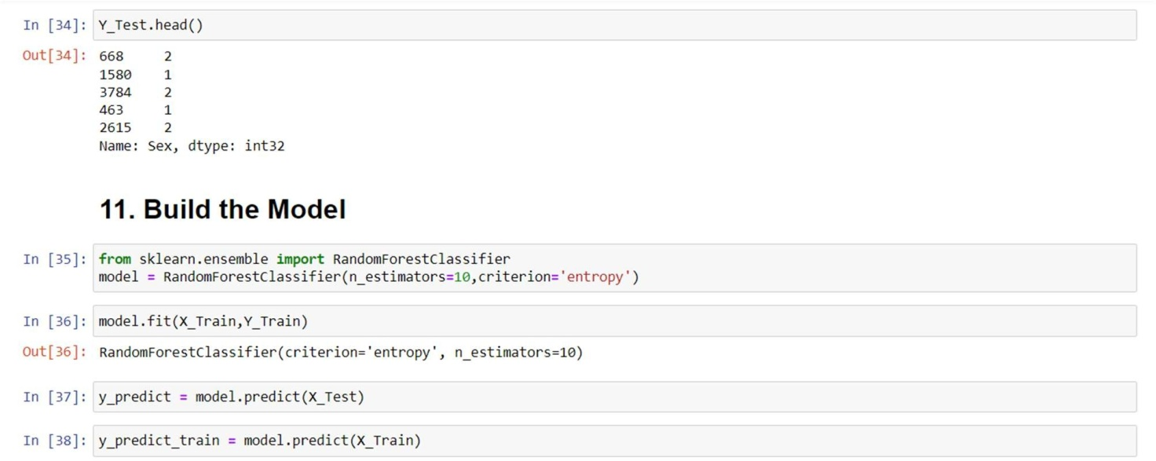



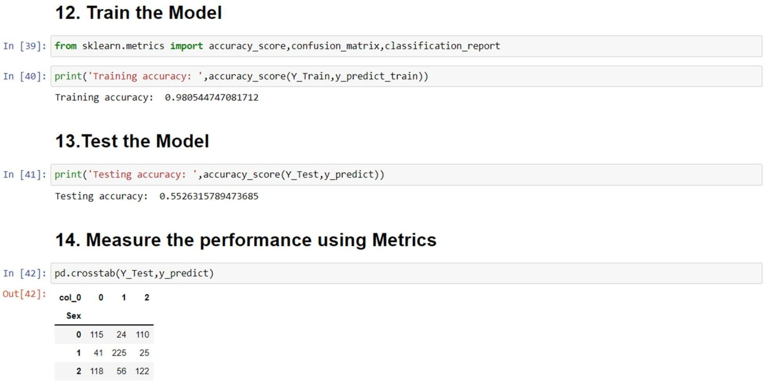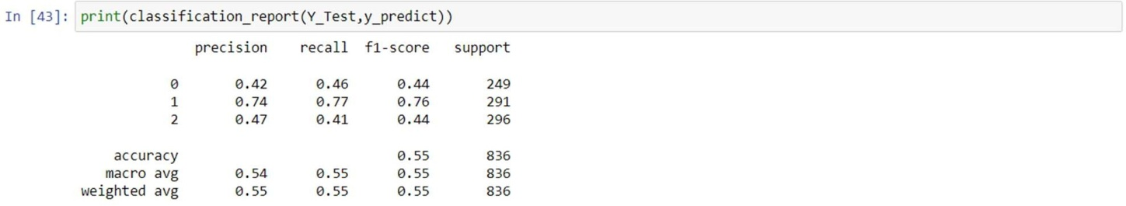

******************************THANKINGYOU***********************************